1. **INTRODUCTION**

**1.1 MOTIVATION**

The shortage of blood donors has risen with the emergence of new diseases, raising the need to enable reliable and efficient blood donation management. The number of donors in the years 2018-2019 were estimated to be 1,36,908 donors contributing to a total of 2,16,639 donations. World Health Organization (WHO) estimates that the annual amount of blood donations collected is 112.5 million units which is approximately 50 million liters per year.

The blood component wastage rates usually run from 1% to 5% and that the amount of disposal is not shared or visible to clarify the reason behind it. Blood donors have three options to donate blood.

• Option 1 - By using healthcare centers.

• Option 2 - Through mobile blood collection units.

• Option 3 - Directly through blood banks.

These are the facts to be consider as a motivation things to this project.

**1.2 PROBLEM DEFINITION**

According to the Food and Drug Administration (FDA) and the American Association of Blood Banks (AABB) standards, red blood cells are stored in refrigerators at 6◦C and have an expired in 42 days.

As per the FDA requirements, plasma is frozen in freezers for up to one year and platelets are stored for up to five days at room temperature.

The Separation, testing, and storage are operated on each donated blood in the blood bank. The separation process is based on separating whole blood units into component of red cells, platelets and plasma through centrifuges.

Testing is performed to verify the blood type and indicate any infectious diseases. When test results are established, units proper for transfusion, then labelled and stored either in refrigerators and freezer lockers or in walk-in cool and freeze rooms.

Several risks are associated with carrying donated blood units in the supply chain. An epidemic in the late 80s occurred because polluted blood infected with HIV was carried out in the supply chain.

**1.3 OBJECTIVE OF THE PROJECT**

**1. Transparency**

Blockchain technology can ensure transparency in the blood donation process by maintaining a secure and immutable record of blood donations, transfusions and inventory levels. This transparency can help build trust among donors, recipients and healthcare providers.

**2. Decentralization**

This decentralization can increase the resilience and accessibility of the blood donation system, especially in regions with limited healthcare infrastructure.

**3. Traceability**

Enabling the tracing of donated blood from donor to recipient, ensuring accountability and enhancing trust in the system.

**4. Efficiency**

Streamlining blood donation processes such as scheduling appointments, recording donor information, managing inventory, improve overall efficiency reduce burdens.

**5. Security**

Enhancing the security of donor data and blood supply chain information through decentralized mechanisms inherent in blockchain technology.

**6. Donor Engagement**

Increasing donor engagement and retention through transparency, gamification elements and incentives embedded within the blockchain-based system.

**7. Fraud Prevention**

Mitigating the risk of fraud such as counterfeit blood products, falsified donations records, by creating an immutable and tamper-resistant record of all transaction.

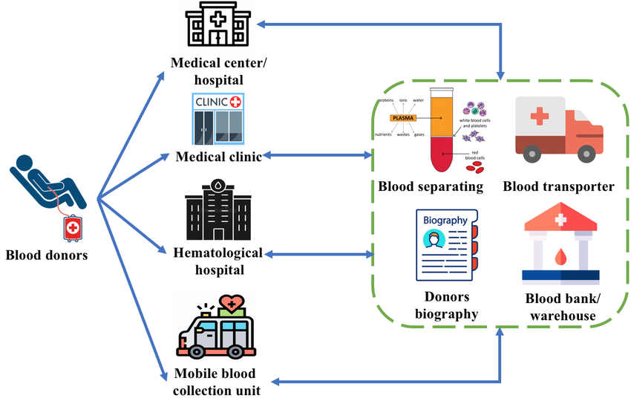

**Fig 1.3.1: Blood donation process based on various platforms**

**Explanation :** The above figure explains about the blood donation process and how the blood donor will donate their blood in various platforms. It is explains about storage of blood, Transportation of blood and store the donor data.